Big Bang Day | Tuesday 6th January - Children will be immersed in a dragon hunting day, with a visit from the Time Capsule Experience! They will also be doing creating lost posters and fire-breathing dragons.
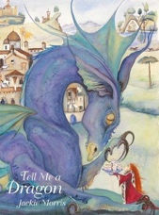
This term pupils will be using a model text of The Tree Dragon to write their own conquering the monster tales. They will be creating their own dragons, orally rehearsing their stories and writing them. The children will also be creating some instructional writing pieces on how to catch a dragon to send back to Tim and his team of dragon hunters.

English
This term the children will be learning about shape, money, multiplication and division. They will be building on their skills of counting in 2s, 5s and 10s and will be applying this knowledge into real life contexts and problem solving.

Maths
History
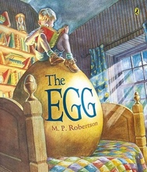
In History this term, the children will be learning about the history of castles, their development over time and some local castles.

In Geography this term the children will be working on their map skills. We will be looking at some aerial photographs of castles and locating different castles on a map.

Art
Geography
Music
Computing
In Art the children will be learning how to print. They will be developing an understanding of what printing is and the purpose of printing, with opportunities to practice different types of printing with a range of mediums. They will finish with a final project designing their own coat of arms, creating a repeated block pattern of this print.

In Music, the children will continue following the glockenspiel course which will start their journey towards reading music notes on the treble clef stave.

R.E.
P.E.
We will be learning about AI (Artificial Intelligence).

We will continue learning about caring for other people and the world around us. They will explore stories from the Bible, learn about the lives of people who help others, such as Mother Teresa or a local helper, and discover Jewish traditions like Tzedakah and Sukkot. Children will see how beliefs can lead to kind actions.
The focus in outdoor PE this term will be Ball Skills where children will explore different movements in a fun and imaginative way. They will practise controlling and coordinating their bodies as they act out being an explorer getting ready for an expedition. For indoor PE, the focus of the learning is to respond to the stimulus using a range of different, controlled movements.
Pupils will show how to control and co-ordinate their bodies to perform movements that represent an explorer preparing for an expedition.

This term the focus is on health and relationships education, where we will be learning about communities and our own strengths.

Personal Development

