|  |  |
| --- | --- |
| Big Bang Day | On Tuesday 3rd June, we will visiting the Golden Hinde ship located in South Bank. We will be uncovering the history of pirates with a workshop. This will be a fantastic and immersive experience for the children. |

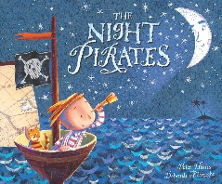

English

The children will be writing adventure stories inspired by the book The Night Pirates focusing on subject-specific vocabulary and continuing to edit and improve our writing. We will be exploring poetry including sea shanties.

Maths

This term the children will develop their learning of place value within 100. We will then move on to money, recognising and counting in coins and notes. The children will also be learning to tell the time to the hour and half hour.

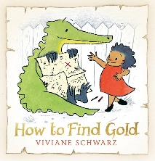

We will be exploring things that are living, dead and have never been alive, food chains and animal habitats. We will also be exploring the characteristics of living things and revisit plants to identify plants that may be found in different habitats.

Science

History

This term the children will be learning about significant pirates and their lives. They will be learning about and discussing piracy, their rules, lives and living conditions. They will also have a look at modern day piracy.

The focus for our indoor this term will be gymnastics. We will continue to build on basic skills such as performing different ways to roll and developing our ability to balance. Our outdoor PE outdoor focus will be striking and field games.

Personal Development

This term we will be learning about what it means to be healthy and why it is important to take care of ourselves through food and exercise, hygiene routines and sun safety.

Religious Education

Physical Education

Music

Computing

Art/D&T

We continue to explore ‘What does it mean to belong to a faith community?’ We will be discussing how babies are welcomed in religions and promises made at weddings. The children will look and reflect on their own network on belonging.

The children will recognise common use of information technology. They will also learn what data is and understand how it can be shared between devices e.g. tablet to a computer to recognise common uses of information technology beyond school.

This term we will be consolidating the different music we’ve learned throughout year. We will revisit songs and consolidate skills through different musical activities.

Our focus is DT this term. The children will be designing, making and evaluating a moving storyboard inspired by our pirate theme. They will be learning about the mechanics of sliders and levers.