Big Bang Day | Tuesday 10th September - We will spend the day exploring different traditional tales. We will be planting beans so that we can observe how they grow and we will write instructions.
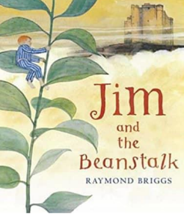
English
This term, children will be revisiting the text Jim and the Beanstalk as they explore a range of traditional tales. The children will explore adjectives, describing characters and settings. They will be innovating and writing our own Jack and the Beanstalk story.
The children will be focusing on numbers within ten. This includes the place value of the numbers and using them in addition and subtraction.
Maths
Science
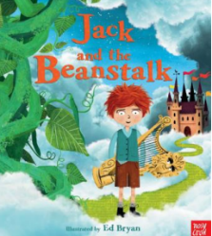
The children will focus on Plants and Seasonal Changes. They will explore the different seasons and their features. They will also be learning about the parts of a plant and what conditions plants need in order to grow.
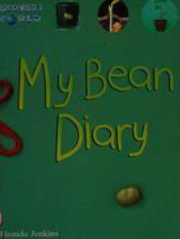
In Health & Relationships this term, the children will be learning about who in our community looks after us.
Personal Development
Physical Education
The children will be learning Invasion Games this term. This will help them to continue to develop their awareness of body movements and teamwork.
Religious Education
Computing
Our key question is “Who is a Christian and what do they believe?”
The children will focus on E-Safety. They will continue to learn the basic functions of an ipad. They will also focus on learning how to take care of digital equipment.
Music
The children will be learning about controlling sounds through singing and playing instruments, including performing.
Art/D&T
Our focus is Art this term. The children will be learning about different types of paint and how to create colour and tone through mixing. They will explore primary and secondary colours as well as exploring different types of brush strokes through the artists; Mondrian and Kandinsky.
Humanities
Our focus is Geography this term. The children will be learning about the United Kingdom and its capital cities. The children will investigate their local area first, then London, and that that moving on to the different countries within the UK.

