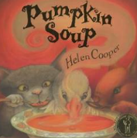
Topic Overview | This term children will learn about popular celebrations. They will learn about celebrations and traditions within their own culture and families and also within other cultures in our community and around the world. We will learn about the festivals and celebrations within different cultures and religions within our community including Diwali, Bonfire Night; Remembrance Day; Birthdays and Christmas.
Big Bang Day | Tuesday 31st October – Let’s celebrate us! Children dress in their favourite clothes or clothes that represent their culture and heritage.
We will be focusing on developing fast recognition of up to 5 objects, without having to count them individually (‘subitising’). Begin to form some recognisable numerals. Talk about and explore 2D shapes (for example, circles, squares, rectangles, triangles) using mathematical language: ‘sides’, ‘corners’; ‘straight’, ‘flat’, ‘round’.
Mathematics
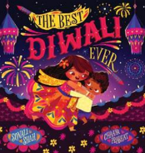
We will learn to read individual letters by saying the sounds for them (phase 2). Blend sounds into words, so that they can read short words (cvc) made up of known letter-sound correspondences. Read a few common exception words. Use some recognisable letters and own symbols. Know there is a sound/symbol (phoneme/grapheme) relationship. Begin to write VC and CVC words by identifying the sounds. Write own name. Form letters from their name correctly. Phonics taught this term – h,b,f,l,ff,ll,ss,j,v,w,x,y,z,zz,qu,ch,sh,th,ng,nk
Literacy

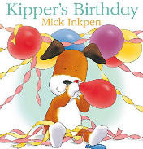
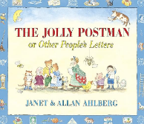
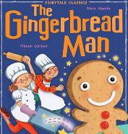
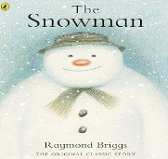
We will increasingly remember and follow rules, understanding why they are important. Play with one or more other children, extending and elaborating play ideas. Find solutions to conflicts and rivalries. For example, accepting that not everyone can be Spider-Man in the game, and suggesting other ideas. We will build confidence in asking adults for help.
Personal, Social & Emotional Development
Communication & Language
We will enjoy listening to longer stories and remember much of what happens. Start a conversation and continue it for many turns. Sing a large repertoire of songs. Develop an enthusiasm for stories and enjoyment of reading. Learn new vocabulary and use new vocabulary through the day.
We will begin to recognise times that are special to themselves as well as others, for example - birthdays, Christmas, Diwali. Continue developing positive attitudes about the differences between people. Talk about what they see, using a wide vocabulary. Recognise that people have different beliefs and celebrate special times in different ways.
Understanding the World
We will explore different materials freely, in order to develop their ideas about how to use them and what to make. Join different materials and explore different textures. Remember and sing entire songs. Create their own songs, or improvise a song around one they know.
Expressive Arts & Design
Physical Development
We will continue to develop pencil control and use scissors with increasing accuracy. Start eating independently and learning how to use a knife and fork. Develop independence as they get dressed and undressed, for example, putting coats on and doing up zips. Increasingly be able to use and remember sequences and patterns of movements which are related to music and rhythm.

