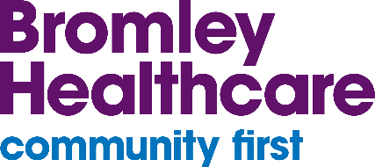

March/April 2025

Tri-borough SEND Newsletter
Bromley Healthcare provides Special Educational Needs and Disabilities (SEND) support to people living in Bromley, Bexley and Greenwich, in partnership with other key professionals and networks.
-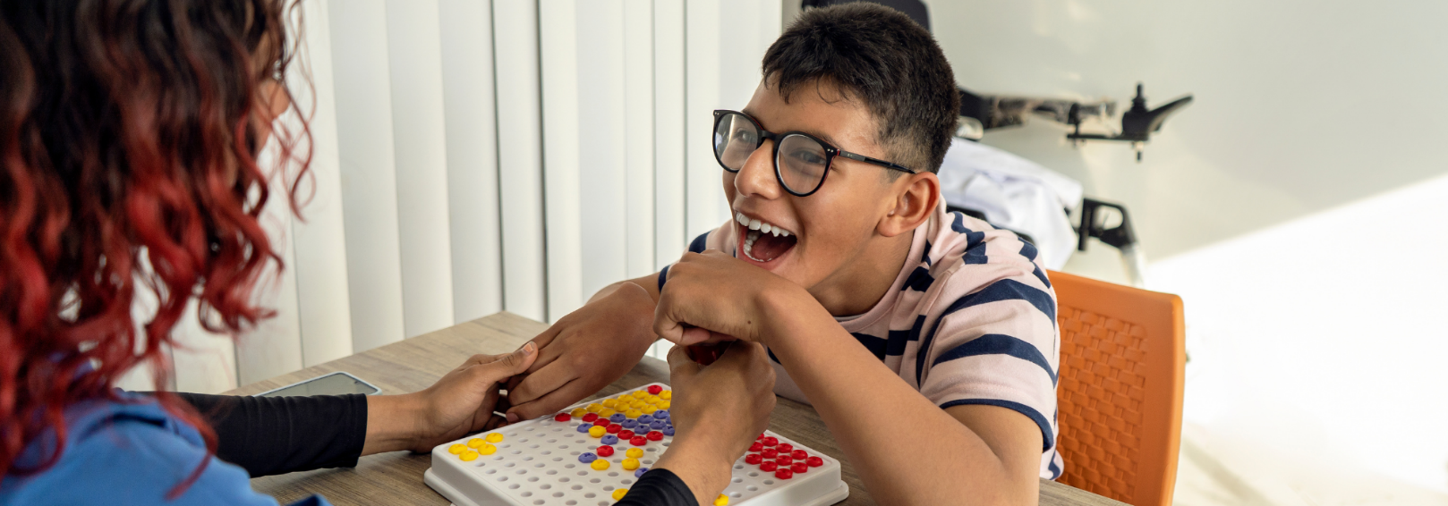
Welcome to the latest edition of the Tri-borough SEND Newsletter! We aim to publish these to you every 6 to 8 weeks. This edition of the newsletter is focusing on world awareness days/months:- World Sleep Day, World Oral Health Day, World Down Syndrome Day, Cerebral Palsy Awareness Month, World Autism Awareness month, Auditory Processing Awareness Day. We have also added a list of useful resource links.
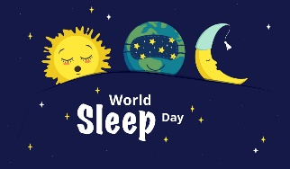  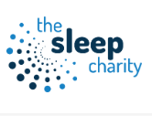  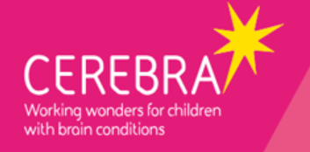     | March 14th World Sleep Day  A celebration of sleep and a call to action on important issues related to sleep, including medicine, education, social aspects and driving.  Children with SEND - The Sleep Charity - If you have a child with additional needs and sleep issues, bedtime can be tricky.  Whether they struggle to communicate how they are feeling, have increased anxiety, sensory issues or social cueing problems, sleeping well may be difficult.  Sleep Advice Service - Cerebra - There Sleep Tips booklet introduces and explains different techniques for you to try that may improve your child's sleep. It covers ten main topics including bedtime routines, daytime napping, comfort objects and moving bedtime backwards or forwards. It gives lots of illustrated hints and tips for putting the techniques into practice.  Parents/carers we haven’t forgot about you when it comes to sleep it can be hard for your child but also for yourself to turn off and sleep. Falling asleep is common and research suggests that almost a third of adults experience chronic insomnia, or persistent difficulties in falling or staying asleep. However, for those of us without insomnia, tossing and turning in bed after a stressful day can be a familiar experience.  Stress and anxiety are often to blame for sleep issues. When our body’s stress response is activated, it can be immensely challenging to fall and stay asleep. Fortunately, research has shown that we can turn off the stress response by activating another natural process, called the relaxation response, and help ourselves drift off to sleep naturally.  Sleep foundation have 5 tested strategies to help you fall asleep fast and relaxation exercises to help you fall asleep.  How to Fall Asleep Fast: 5 Tested Strategies (sleepfoundation.org)  Relaxation Exercises to Help Fall Asleep (sleepfoundation.org)  Clock change bedtime tips  In the UK the clocks go forward 1 hour on Sunday 31st March at 1am. The clocks changing in spring can wreak havoc with your little one’s sleep schedule.  Try CBeebies survival strategies to help you manage the wibbly wobbly timey-wimey stuff…  Clock change bedtime tips - CBeebies  With many parents struggling to adjust their little ones to new sleep patterns, when the clocks spring forward on the last Sunday in March, children in particular toddlers and babies, can find it hard to instantly adjust to the new ‘time zone’. The loss of a whole hour, if not managed properly can turn a smooth evening routine into chaos as kids, especially babies, don’t understand what’s going on as their body clock is set at the ‘usual time’  Here are 5 tips to help smooth the process:  - Move bedtime back early – a week or a long-weekend works best  - Bedtime routine is key  - Plan an active Saturday  - Use signals to reinforce routine  - Be patient  Check the links below from The sleep site for more tips.  How To Help Your Child Sleep When The Clocks Change This Spring | The Sleep Site | Dave Gibson  How To Get Baby Back On Schedule When The Clocks Change | The Sleep Site | Dave Gibson  Family sleep tips for the clocks change this March  Last Minute Tips For The Clocks Going Back | The Sleep Site | Dave Gibson
  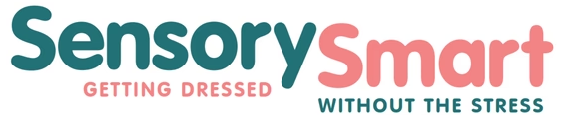 | March 20th World Oral Health Day  Oral health day is celebrated globally every year on 20 March. Organised by FDI World Dental Federation. World Oral Health Day aims to empower people with the knowledge, tools and confidence to secure good oral health.  Resources to spread the word | World Oral Health Day  Are you struggling to get your Neurodivergent child or young person to brush their teeth? Parents of children with SEND, especially when sensory processing sensitivities, OCD, PDA, or Autism are in the mix, often struggle to get a toothbrush anywhere near their child, let alone work on improving gum health or oral hygiene. This can lead to distress, meltdowns and anxiety twice a day, every day, and that’s no fun for anyone. We would never suggest there is an easy ‘one size fits all’ solution, but Sensory Smart do know there are some ideas, tips, strategies or tools that have helped some of the children struggling.  Are you struggling to get your child with special needs to brush their teeth | Sensory Smart  Brush teeth tips from the Witherslack Group  Teeth Brushing Tips For Children With Autism & ADHD - Witherslack Group
  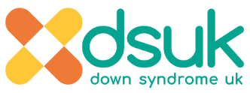  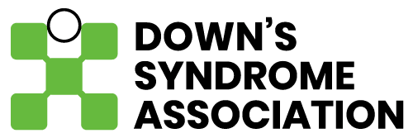    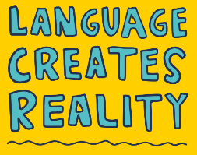  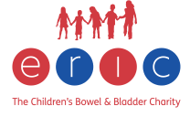  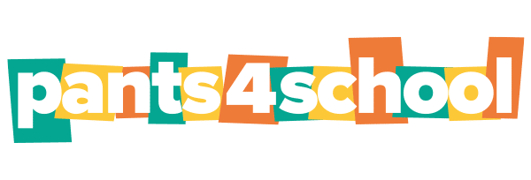 | March 21st World Down Syndrome Day  The 21st day of the 3rd month, was selected to signify the uniqueness of the triplication (trisomy) of the 21st chromosome which causes Down syndrome.  Below are charities, services and resources to support children and their families:-  Down Syndrome UK is a national charity that’s passionate about empowering parents and professionals to improve the lives of those with Down Syndrome and their families.  Home: DSUK - Down Syndrome UK  The Down’s Syndrome Association  The Down’s Syndrome Association is the only charity in the UK providing support for all aspects of Down’s syndrome. Their aim is to enable people who have Down’s syndrome to live full and rewarding lives. From before birth into older age, the DSA provides services to everyone.  The team of specialist advisers offer advice about any aspect of living with Down syndrome including prenatal support, benefits, education, service provision, rights, health, speech, language and communication, complex and adult needs.  www.downs-syndrome.org.uk  Down Syndrome Education International  Down Syndrome Education international deliver evidence-based resources around the world that help families and professionals to provide effective teaching approaches and interventions.  DSE Online (down-syndrome.org)  Language creates reality  Supported by the Down Syndrome Association, Language creates reality is a creative collaboration that focuses on the importance of language when talking about Down Syndrome. Language Creates Reality  ERIC  ERIC, The Children’s Bowel & Bladder Charity is the UK’s leading charity supporting all children and teenagers with a bowel or bladder problem.  Pants 4 school  Potty training children with Down syndrome: Together with Down Syndrome UK and Positive about Down syndrome Eric promote their #Pants4school Step by Step Programme. Home - ERIC
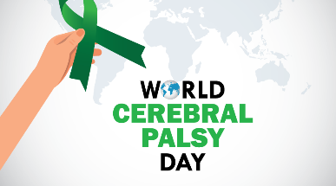    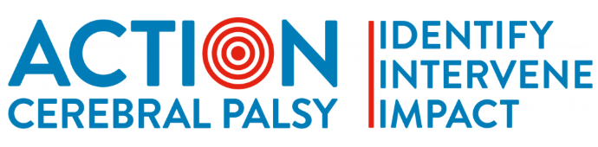 | March 25th Cerebral Palsy Awareness Month  March is Cerebral Palsy Awareness Month, and March 25 is an entire day devoted to awareness of this common cause of disability. Created in 2006, the day and the month came from a need to recognize the lack of progress in cerebral palsy research. Cerebral palsy is the most common motor condition that causes lifelong disabilities. March is set aside as a time to recognize this and to raise awareness about all aspects of cerebral palsy.  Scope  Cerebral palsy is a condition that affects muscle control and movement. It affects about 1 in every 400 children in the UK. Cerebral palsy (CP) | Disability charity Scope UK  Action Cerebral Palsy  Each child is unique. Action Cerebral Palsy aim to be a source of practical information about the care, services and support available to you and your family at each stage of your journey.  Action Cerebral Palsy | For Parents (actioncp.org)
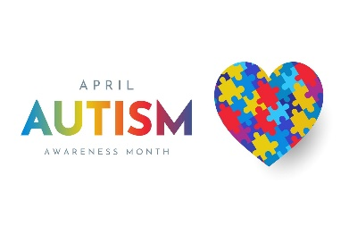  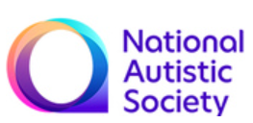  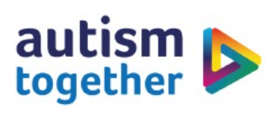   | April 2nd World Autism Awareness Month  World Autism Acceptance Week will become World Autism Acceptance Month!  National Autistic Society  World Autism Awareness Month is an opportunity for everyone to come together and raise awareness, foster acceptance, and create a society where autistic people are supported, understood, and empowered. Whether you’re at home, at school, or at work, your involvement can make a real difference. It’s about how you show up - whether you’re supporting your autistic colleagues, students, or family members, your actions can help create an inclusive and accepting world.  This year, help the National Autistic Society change attitudes towards autism. Your support can help create a world that works for autistic people and their families.  National Autistic Society (autism.org.uk)  Acceptance and awareness (autism.org.uk)  Autism Together and Ambitious about Autism  Autism Together providers support to people with autism and their families. They campaign on behalf of all individuals affected by autism, they encourage all supporters to get involved with fundraising and volunteering with them and offer comprehensive training and job development to our employees.  About Autism – Autism Together  Ambitious about Autism | National charity for autistic children and young people
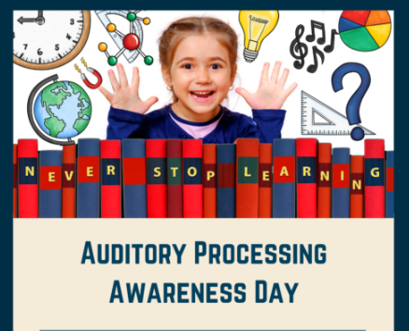  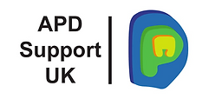  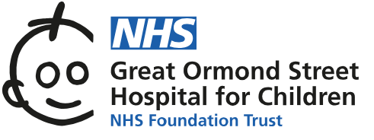  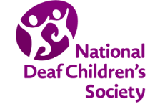 | April 4th Auditory Processing Awareness Day  The Hearing Health Foundation mark auditory processing disorder awareness day each year to highlight the effects and challenges associated with living with auditory processing disorders.  APD Support UK  The aim of this website is simply to provide accurate information about Auditory Processing Disorder/APD and links to support for living with this disabling condition. HOME | Apdsite (apdsupportuk.wixsite.com)  Great Ormond Street Hospital (gosh)  Auditory process disorder (APD) affects how the brain interprets sound rather than how sound is carried through the ear to the brain.  Auditory processing disorder | Great Ormond Street Hospital (gosh.nhs.uk)  National Deaf Children’s Society  National Deaf Children’s Society only provide support and services to families and carers of children and young people with Auditory Processing Disorder (APD) if your child is deaf or has hearing loss.  APD and childhood deafness | APD and deafness support (ndcs.org.uk)

Useful resources
 | Sibs  Sibs exists to support people who grow up with or have grown up with a disabled brother or sister. It is the only UK charity representing the needs of over half a million young siblings and over one and a half million adult siblings. Home - Sibs
 | Advise on ways to support your child/young person to brush their teeth  Looking after teeth for children with additional needs (royaldevon.nhs.uk)  Take Care of Teeth in SEND Children | Better Health North Somerset (betterhealthns.co.uk)
 | Makaton  Over 100,000 children and adults use Makaton symbols and signs, either as their main method of communication or as a way to support speech.  The Makaton charity has a library of free resources, training workshops and the sign of the week.  Home (makaton.org)
 | IHV good practice points  iHV’s Good Practice Points (GPPs) are evidence-based resources to support everyday health visiting  Topics covered include: Babies and young children with eating drinking and swallowing difficulties, Supporting babies and children with Down syndrome and their families, Supporting children with Down syndrome: Growth feeding and development.  ihv.org.uk/for-health-visitors/resources/good-practice-points/
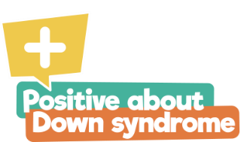 | Positive about Down Syndrome  For any expectant parent in the UK with a high chance or confirmed result that baby has Down syndrome please join our Great Expectations group, where you will find a very supportive non-judgemental, friendly group of women there to help you however they can.  The little orange book of knowledge highlights the support that different services can offer to families and their children.  www.positiveaboutdownsyndrome.co.uk
 | What is a Hospital Passport?  It is important to get help with your health when you need it.  Find out about hospital passports, the learning disability register, reasonable adjustments and how to ask for help.  Health Guides: Hospital Passports, Summary Care Records And Flu Jabs | Mencap
     | Tri-borough Local Offers  The Local Offer is a document that gives information about the support services available in your local area. This specifically for children, young people and their families with Special Educational Needs and / or Disabilities (SEND).  About the Bromley Local Offer | London Borough of Bromley  Home | Bexley Local Offer  About the Local Offer | Royal Borough of Greenwich

Get to Know Your Local Children and Family Centres
Royal Borough of Greenwich Children's centres | Royal Borough of Greenwich
Bexley About the Children's Centres | London Borough of Bexley
Bromley Children and Family Centres (bromley.gov.uk)
Should your you require any further support or information, please contact the Health Visiting Tri-borough SEND Specialists at:
Contact: bromh.tri-boroughsendchampions@nhs.net
Please also follow us at the following social media platforms:
  @Bexley0to19  @Bromley0to19  @Greenwich0to4 |  |   Bexley 0 to 19  Bromley 0 to 19  Greenwich 0 to 4 |   @bexley_0to19  @bromley_0to19  @greenwich_0to4
We want to hear your feedback on our services. Visit careopinion.org.uk/youropinion.

