Topic Overview
Big Bang Day
This term we are learning all about London from famous landmarks to The Great Fire of London and how we travel in London.
Big Bang Day – Celebrating our fire service with links to The Great Fire of London.
Big Bang Day
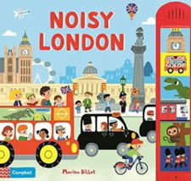
Children will mark make, write their name and use their phonic knowledge to write words and simple sentences relating to the topic. They will explore and read books based on their phonic knowledge. They will respond to simple questions about the key text.
English


Maths
Children will build numbers beyond 10, explore patterns beyond 10. They will count and create patterns to 20.
Children will draw information from a simple map. They will show interest in different occupations.
They will use all their senses in hands-on exploration of natural materials and explore collections of materials with similar and/or different properties.

Understanding the World
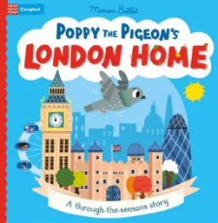
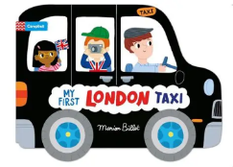
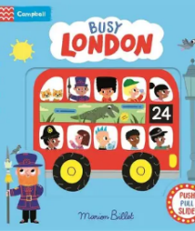
Children will explore different materials, using all their senses to investigate them. Manipulate and play with different materials and make simple models which express their ideas. They will express ideas and feelings through making marks and give a meaning to the marks they make.

Art/D&T
Children will use musical instruments to create music patterns (loud and soft, fast and slow) . They will move and dance to music.

Music
Children will be encouraged to use subject specific vocabulary in context (i.e. name the resources they want and or are using). they will show understanding by responding to what they hear with gesture, pecs or words. The children will be guided to use words, gesture (Makaton) or visuals to request something they need (toilet, water, food, help).

Communication and Language
Children will explore activities such as squeezing, pinching, threading, or manipulating objects to build hand strength. Children will practise using tools such as scissors, pencils, crayons, or adapted equipment with adult support.

Physical Education
Children will use visuals, gestures, symbols, or AAC to show how they are feeling (e.g. happy, sad, worried) and begin to understand that feelings can change. They will engage in shared activities with an adult and peers, showing awareness of others through turn-taking, waiting, or joint focus.

Personal Development

