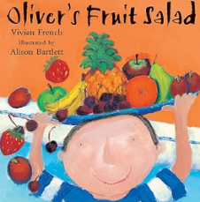
Topic Overview | We’ll find out why we can’t eat chocolate for every meal, which foods are healthy and how to live a healthy lifestyle. We will learn about oral hygiene and how to look after our teeth and our bodies.
Big Bang Day | Tuesday 4th Jue  Making Fruit Salad – children bring their favourite fruit or unusual fruit to contribute to making a fruit salad
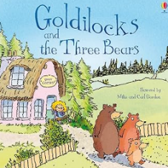
Mathematics
This term children will learn that to share we need to take one object at a time, repeating this process until all the objects are gone. Learning that when you share you make it fair. They will look at deepening their mathematical understanding through developing their reasoning skills and problem-solving strategies.

Literacy
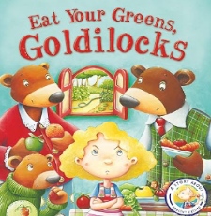
Children will be able to re-read what they have written to check that it makes sense. Read aloud simple sentences and books that are consistent with their phonic knowledge, including some common exception words. Recall the main points in text in the correct sequence, using own words and include new vocabulary. Use a pencil confidently to write letters that can be clearly recognised and form some capital letters correctly. Write short sentences with words with known letter-sound correspondences using a capital letter and full stop.
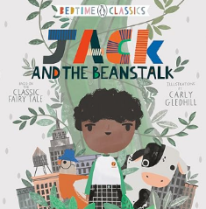
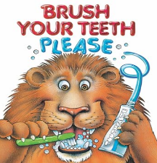
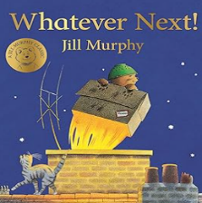
Personal, Social & Emotional Development
Children will be confident to try new activities and show independence, resilience and perseverance in the face of challenge. Manage their own basic hygiene and personal needs, including dressing, going to the toilet and understanding the importance of healthy food choices.
Communication & Language
Children will use past, present and future forms accurately when talking about events that have happened or are to happen in the future. They develop their own narratives and explanations by connecting ideas or events.
Understanding the World
Children will plant seeds and care for growing plants. Understand the key features of the life cycle of a plant. Understand the past through settings, characters and events encountered in books read in class and storytelling.
Expressive Arts & Design
Children will make use of props and materials when role-playing characters in narratives and stories. Invent, adapt and recount narratives and stories with peers and their teacher.
Physical Development
Children will learn and talk about the different factors that support their overall health and wellbeing: - regular physical activity - healthy eating - tooth brushing - being a safe pedestrian. PE will develop ball skills with hands. Children show good control and co-ordination in large and small movements

