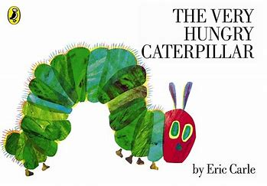
Topic Overview | As the weather gets warmer we will be taking the opportunity to head outside and discover the wonderful world of minibeasts. We will be exploring outside, looking for different minibeasts and how to take care of them.
Big Bang Day | Tuesday 16th April 2024 - The Big Bug Ball – dress up as a minibeast
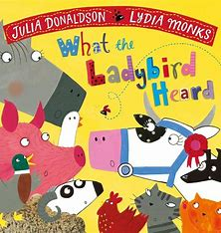
This term we will be exploring numbers beyond 10, counting accurately to 20 and looking at the pattern between 1-10 and 11-20. We will also be looking at adding and subtracting single digit numbers using mathematical language to explore addition and subtraction.
Mathematics

We will consolidate phonics phase 2 and 3 skills. The children will read simple phrases and sentences made up of words with known letter–sound correspondences and, where necessary, a few exception words. They will anticipate key events in stories and respond to questions about how and why something is happening. Write a simple sentence using finger spaces between words and begin to remember to use a full stop.
Literacy

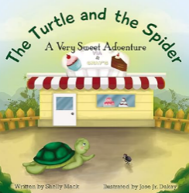
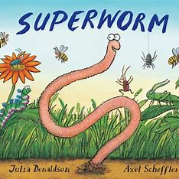
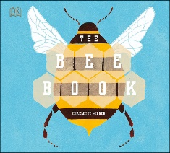
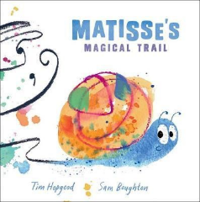
Children will show sensitivity to others’ needs and feelings, and continue to form positive relationships with adults and other children. They understand the rules and positive behaviour including sharing and taking turns with others. They will listen attentively and respond appropriately.
Personal, Social & Emotional Development
Children will begin to explain how things work and predict what might happen. They will use talk to help work out problems and organise their thinking. Children will describe minibeasts and learn about the life cycle of a butterfly. They will ask and answer how and why questions about stories and events.
Communication & Language
Children will plant seeds and care for growing plants. They will understand the key features of the life cycle of a plant and an insect. They will begin to understand the need to respect and care for the natural environment and all living things. They will explore the natural world around them and draw information from a simple map.
Understanding the World
Expressive Arts & Design
Children will safely use and explore a variety of materials, tools and techniques, experimenting with colour, design, texture, form and function. They will share their creations, explaining the process they have used. They will create a dance in response to music.
Physical Development
Children will handle equipment and tools effectively, including pencils for writing. In PE lessons, children will learn and practice the skills needed for sports day.

