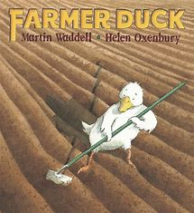
Topic Overview | Are eggs alive? What are buds? It’s time to find out more about the things that happen in the world around us during spring and Easter. We will learn about the lifecycle of a bird and look at similarities and differences between animals.
Big Bang Day | Theatre Box visiting workshop – drama and dance based on The Ugly Duckling.
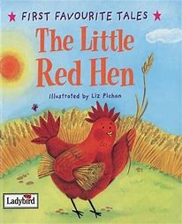
Children will explore and compare the length and height of objects. They will use time vocabulary to explain events. They will explore some 3d shapes, naming and describing the shapes including a sphere, cube and cuboid. They will find, compare and represent numbers 9 and 10. They will continue to develop their subitising skills and numer bond knowledge.
Mathematics

Children will consolidate and secure phase 3 phonics. Read simple phrases and sentences made up of words with known letter–sound correspondences and, where necessary, a few exception words. They will begin to write a simple sentence with support as well as begin to read their own writing.
Literacy
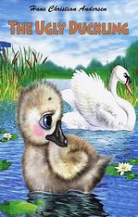
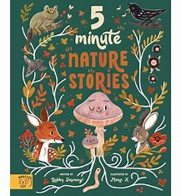
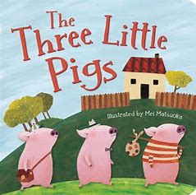
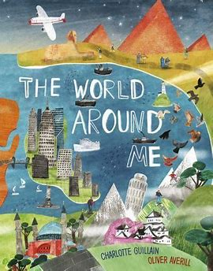
Children will begin to think about the perspectives of others through sharing their ideas, thoughts and feelings. Show resilience and perseverance in the face of challenge. Identify and moderate their own feelings socially and emotionally.
Personal, Social & Emotional Development
Children will be able to listen to and talk about stories to build familiarity and understanding. Retell the story, once they have developed a deep familiarity with the text, some as exact repetition and some in their own words. Ask questions to find out more and to check they understand what has been said to them.
Communication & Language
Children will understand that some places are special to members of their community. Know that there are different countries in the world and talk about the differences they have experienced or seen in photos. (Linked to their own family – cultural capital) Recognise some similarities and differences between life in this country and life in other countries where family live. They will begin to recognise some environments that are different to the one in which they live.
Understanding the World
Children will explore, use and refine a variety of artistic effects to express their ideas and feelings. Return to and build on their previous learning, refining ideas and developing their ability to represent them. Create collaboratively through sharing their ideas.
Music
• Explore patterns in music (link to maths)
• Play instruments with increasing control to express their feelings and ideas.
• Create collaboratively sharing ideas, resources and skills.
Children will be learning and developing ball control skills in PE. Children will develop the foundations of a handwriting style, which is fast, accurate and efficient.. They will show good control and co-ordination in large and small movements.
Expressive Arts & Design
Physical Development

