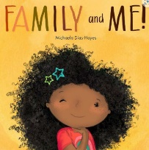
Topic Overview | We will be finding out all about ourselves and our friends – we will focus on settling into the school routines as well as our school rules: Respect, Listen, Ready. We will focus on developing self-confidence, enabling children to talk about themselves and their families with others. We will work on developing friendships with peers, enjoying school with others who share similarities but also differences.
Big Bang Day | 14th September – We would love to see photos of everyone as a baby! Please upload to Showbie. The children will be sharing and talking about their photos on the day!
Mathematics
We will be focusing on recognising numerals and being able to count reliably. We will match and sort (matching pairs, sorting by one more criteria), making comparisons (compare quantities – same, more than, fewer than, more, less, compare and order objects by size).
Literacy
We will learn to recognise our names and understand that print has meaning. We will learn how to handle books correctly and turn one page at a time. We will start our Little Wandle phonics learning with an initial focus on sounds: s a t p i n m d g o c k ck e u r. We will give meanings to marks and practice writing our name. We will begin to form some recognisable letters correctly.
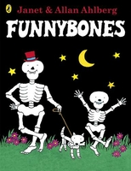
We will learn to select and use activities and resources correctly, with help when needed. We will learn and follow class rules including sharing and taking turns. We will learn to talk about our feelings using words like happy, sad, angry, worried, and will develop an understanding of how others might be feeling.
Personal, Social & Emotional Development
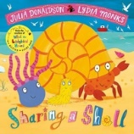
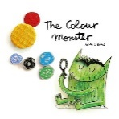
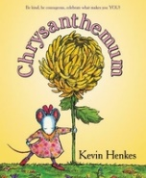
We will develop fine motor skills and begin to use a correct pencil grip (tripod grip). We will become increasingly independent in meeting own care needs including toileting, washing hands, dressing/undressing and moving confidently and safely.
We will engage in pretend play, use an object to represent something else and begin to develop more complex stories using small world equipment. We will create closed shapes with continuous lines and begin to use these shapes to represent objects. We will learn and join in with a range of songs and rhymes.
We will begin to make sense of our own life story and family history by talking about family. We will begin to develop an understanding of similarities and differences between ourselves. We will use all the senses in hands on exploration of natural materials.
We will learn to develop listening and attention skills through developing an enjoyment of stories. We will learn to respond to stories including joining in with repeated refrains and phrases. We will develop out understanding of stories as well as develop talking in clear simple sentences to answer questions as well as use talk to organise and play. We will begin to understand a question of instruction that has two parts.
Physical Development
Expressive Arts & Design
Understanding the World
Communication & Language

