Dear Parents and Carers,
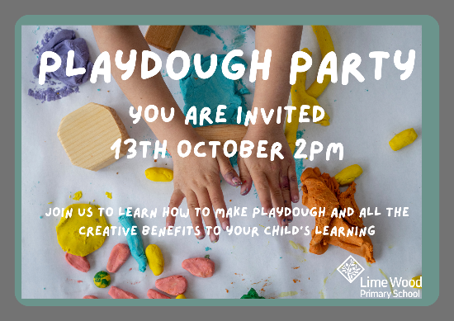

We are happy to say that your children have settled into learning in their new classroom quickly and enthusiastically. In order to celebrate their success in this transition we would like to invite you to a Playdough Party on 13th October, from 2pm.

You will be able to make playdough and learn about the fantastic benefits that play dough has to offer your child including improving their writing. We can only offer space for 1 adult per child due to limited space, we also ask younger siblings do not attend.

In order to ensure we have enough resources for the party, please return the below reply slip by Monday 2nd October 2023.

We look forward to you joining us.

Yours sincerely,

Mrs Holdsworth and Mrs Webber
----------------------------------------------------------------------------------------------------------------------

Reply slip – PLEASE RETURN TO SCHOOL OFFICE

I am able / I am unable to attend the Playdough Party on 13th October, 2023.

Childs name

Name of person attending

Signed

