Dear Parents, Carers & Families,

At Lime Wood Primary School, our chosen programme for Phonics and Early Reading is delivered using the Little Wandle Letters and Sounds scheme.

We will be sharing further information about the teaching and learning of Phonics in Autumn term. In the meantime, please see below link to a range of documents that can be found on our school website that you may find of use as you start to prepare your child to start school.

www.limewoodprimaryschool.co.uk/ourcurriculum/eyfs/
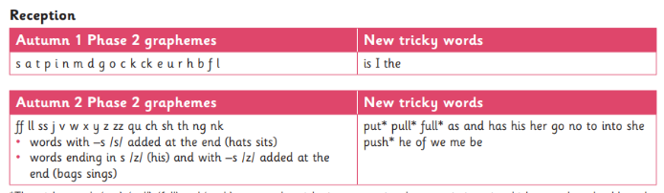
Little Wandle Programme – Progression for Reception and Year 1

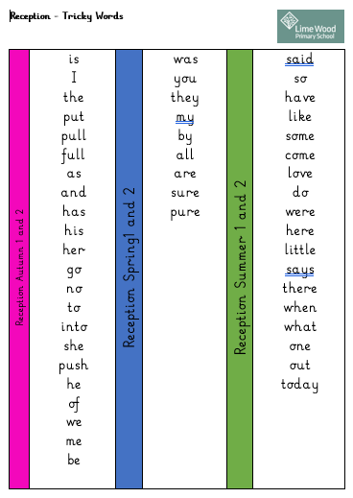
Tricky Words – Reception

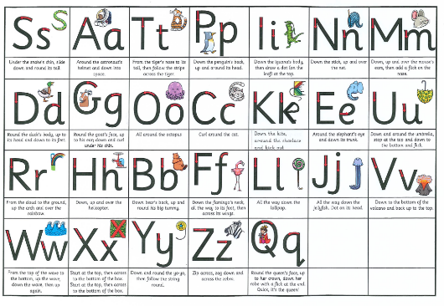
Handwriting Mat

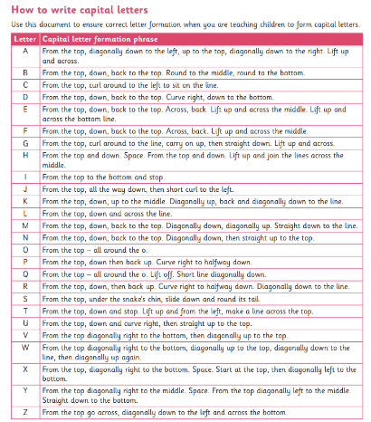
Capital Letter Formation

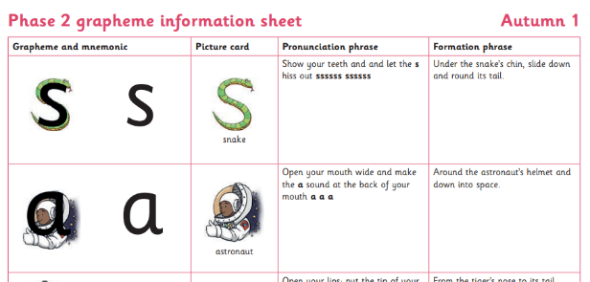
Phonics Pronunciation Guide – Reception Autumn 1

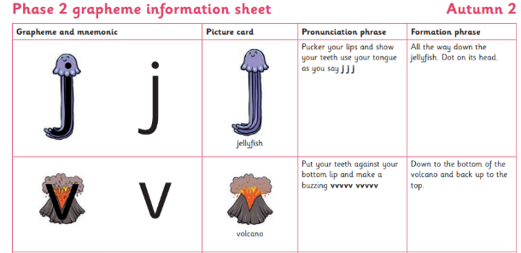

Phonics Pronunciation Guide – Reception Autumn 2

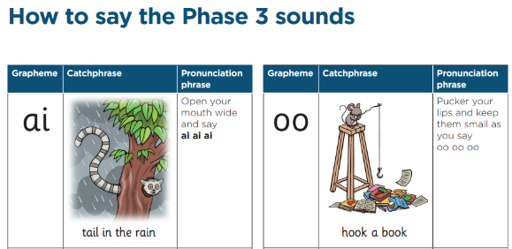
Phonics Pronunciation Guide – Reception Spring 1

We hope you find this useful.

Yours sincerely,

Miss C Ingrams
Headteacher

