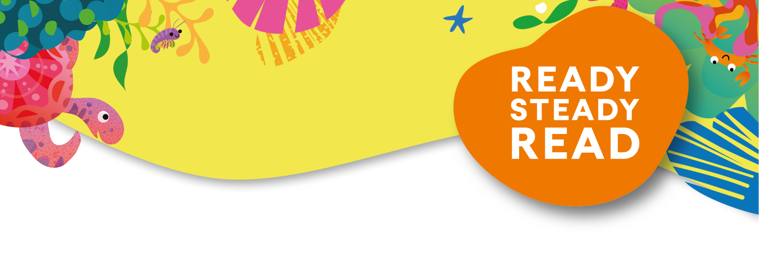

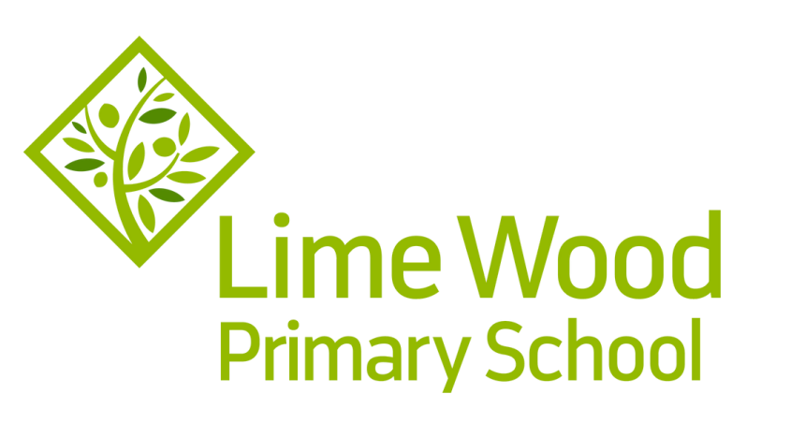

Friday 3rd November 2023
Dear Parent/Guardian,

To celebrate and encourage a lifelong love of reading at home and school, we are running a sponsored read between 10 November 2023 - 17 November 2023.

The project is being organised in conjunction with our local Usborne Partner, Karen Harwood and all the money raised will go towards brand new books for our school. In addition to the sponsorship money, Usborne will also donate up to 60% of the total raised in EXTRA FREE BOOKS to the school. So, for every £600 raised, we will get an extra £360 in FREE Usborne books!

Please help us to enhance our reading resources for pupils by encouraging your child to spend a small amount of time each day either reading to themselves, to others, or being read to. They can read books, comics, magazines, newspapers, menus, websites, recipes, poems, leaflets, instructions – anything with words!

If you are able to support our sponsored read, please find enclosed a sponsorship form and reading log for your child if they wish to use it to record their reading. Please could all sponsorship money be received by the office in cash, in a named envelope by Friday 24 November 2023. There is absolutely no obligation to take part.

The week will end with a Book Fayre, on Friday 17th November after school, where you will be able to purchase books should you wish.

We hope this will be an enjoyable experience for our children.

If you need any more information, please contact the school office lwpoffice@watschools.org.uk
Yours Sincerely,
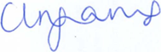
Miss C Ingrams
Headteacher

