|  |  |
| --- | --- |
| Big Bang Day | On Wednesday 23rd April, we will have our Big Bang Day to launch our topic. We will be enjoying a variety of activities inspired by the topic including team building skills, a scavenger hunt and making our own bread. |

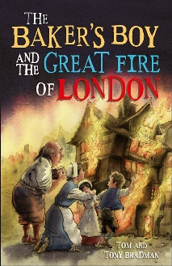

The children will be using the text Baker’s Boy and the Great Fire of London. They will be focusing on using adjectives to describe the scenes of the Great Fire of London and writing diaries in role as someone who has experienced the fire.

English

This term the children will be introduced to the concept of multiplication, division and fractions. Please support them in practising their times tables - x2, x5 and x10.

Maths

The children will build on their knowledge of materials and their properties to explain why the fire spread and the impact of houses being made from wood had on the spread of the fire.

Science

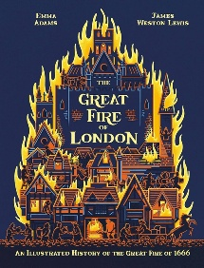

History

The children will be exploring the Great Fire of London in 1066. They will be developing their enquiry skills about sources and the changes this led to for London.

Our key question this term is ‘What does it mean to belong to a faith community?’ We will be discussing which communities we belong to and link this to how religious people belong in communities.

In Health & Relationships this term, the focus will be on pride, aspirations and achievements. Pupils will focus on how to show pride and celebrate the achievements of others.

The focus for this term will be on dance and movement.

The children will be introduced to Robotics through Bee-Bot. We will be recognising and naming the buttons and symbols, planning and sequencing commands through directional language and then debugging sequencing for errors.

The children will be learning about different styles of music through singing and playing instruments. Our song this half term is ‘Your Imagination’, a song focusing about using our imagination.

Physical Education

Personal Development

Our focus is DT this term. The children will be exploring how to create a slider and lever for a moving picture. They will generate ideas from our topic The Great Fire of London to create moving pictures inspired by this.

Art/D&T

Music

Religious Education

Computing