Celebrating British Science Week
British Science Week was a huge success here at Lime Wood, thanks to the brilliant planning of Miss Willard, a Year 1 teacher. Our whole school was alive with curiosity and discovery as we explored the world of science through exciting experiments, inspiring scientists, and hands-on learning.
Throughout the week, each year group focused on a celebrated scientist, diving deeper into their area of expertise and conducting related experiments. Classrooms were full of wonder as children became scientists themselves—predicting, observing and investigating in true scientific style.
The science didn’t stop at the school gates! Families were challenged to create and conduct their own experiments at home, with children encouraged to upload their results on Showbie. We were blown away by the creativity and enthusiasm shown—from erupting volcanoes and colour mixing to floating and sinking investigations. It was especially wonderful to see so many children confidently sharing their predictions and observations in video form, showcasing their developing oracy skills. Judging a winner for each class was no easy task!

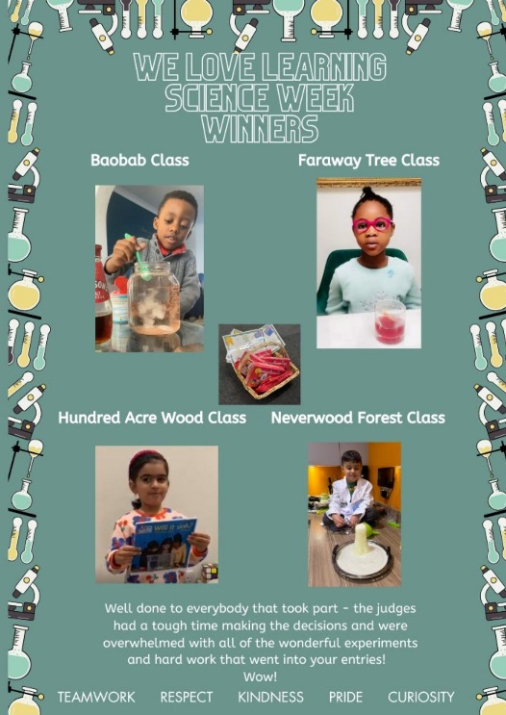
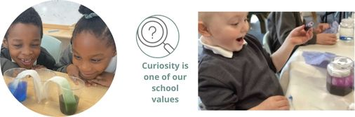
To top it all off, we connected with Climate and STEM Ambassadors through the STEM portal, and were delighted to welcome Dr Clarke, a STEM Ambassador, into Year 1 to talk about battery power and the importance of recycling.
Inspired by the visit, we’ve now launched our own battery recycling drop-off point in school—and one of our very enthusiastic Year 1 has already got the collection started!
British Science Week truly sparked a love of science across our school community. We can’t wait to see where our curiosity takes us next!
