D

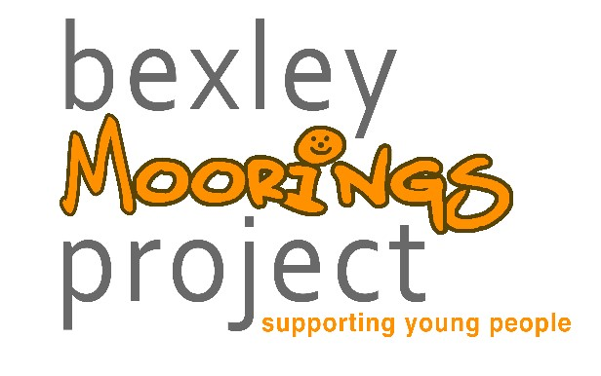

**SOCIAL SKILLS / CONFIDENCE**

**GROUP**

**8**

**-**

**17**

**years**

A weekly group for young people

needing

support around

general

social skills as well as more targeted

work for those with suspected or

diagnosed autism

requiring low

level or early intervention to

develop

their

social interaction

skills

and communication

. The aim of the

group is to build resilience,

confidence and social skills

.

O

pen referral including school, GP,

parent/carers and social care.

D

**FLARE**

**PARENT / CARER NETWORK**

This group is open to all parents and

carers within the Bexley borough.

As a FLARE member you will have

access to regular training and

workshops, all completely free.

We will offer a listening ear,

practical advice and signposting to

local services.

Contact us:

[jayne@bexleymoorings.co.uk](mailto:jayne@bexleymoorings.co.uk)

Or join

us on Facebook: Bexley Flare Parent

Group

D

**EPEC**

**Empowering Parents**

**Empowering Communities**

A

variety of parent led courses and

workshops which cover the

following topics:

-

Being good enough, feelings, play,

understanding behaviours, discipline

strategies, listening and

communicating, coping with stress.

Courses run

several time

s per year

at various venues

across

the

borough

.

T

o register your interest

or for more

information

email

:

karen@bexleymoorings.co.uk

D

**COGNITIVE BEHAVIOURAL THERAPY**

**8**

**-**

**17**

**years**

This service is triaged through

Bexley CAMHS. CBT

is talking

therapy with clear goals. The

therapist and young person will

collaboratively identify areas of

difficulty on which to focus and help

the young person to understand

their thoughts, feelings and

behaviours. This offers the

opportunity to look a

t reacting in a

positive way to challenges that they

face now and in the future.

Referral via CAMHS or Social

Prescribing

D

**BEFRIENDING**

**10**

**-**

**years**

**15**

Volunteers are screened and trained

before being matched with a young

person

.

Befriending provides one

-

to

-

one

intensive support, including listening

and help with behaviour

management

.

The

service offers the

young person

a

positive role model

to discuss

problems with

and

who can

encourage them to try new activities

and build up their confidence.

They meet for a couple of hours

weekly

and matches are usually for a

period of 4

months.

This is a time limited, solution focused

model with measurable objectives.

Referral is open to Social Care and the

Family Wellbeing Team.

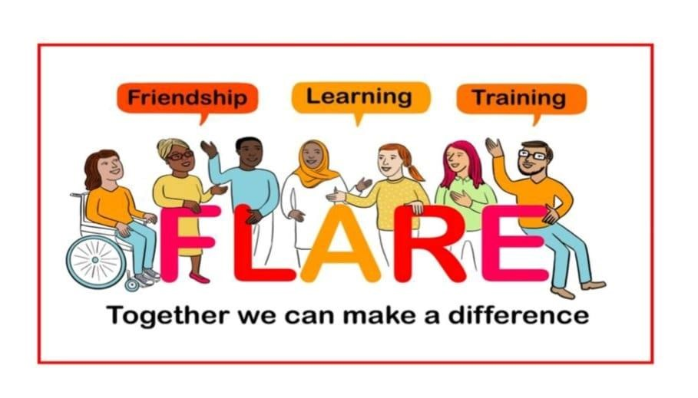

All of our parent courses are free of charge to parents across Bexley Borough. For further information about any of the services which we offer, please email: info@bexleymoornings.co.uk